Work Activity Brief

Course (s) | Level 2 Engineering
Project Title | Preparation for Working in an Engineering Environment
Tutor/s | David Fairbairn
Issue date | April 2020 | Completion date | August 2020

Project overview

Welcome to the Engineering Summer Project for 2020.

This individual research activity has been designed to help prepare you for your chosen course. Please attempt to complete all the activities to the best of your ability, using a variety of research methods.

If you do not have a printer, please do not worry, you can simply add your answers separately on a new Microsoft word document.

Once you have completed your project, please forward this to the following email address along with your full name: submissions@esc.ac.uk. We’ll then forward this on to our curriculum teams who will be in touch shortly.

Outcome of the project

This project has been developed to help you to prepare for the programme that you will be joining in September. It will hopefully give you some insight in to the subject area and will support the development to working independently as well as assignment writing.

Brief – These are the tasks that you need to complete:

Task 1: Hazard Spotting

Task 2: Personal Protective Equipment

Task 3: Fire

Task 4: Safety Signs

Task 5: Engineering Maths & Science

Task 6: Shape Drawing

Task 7: Written Essay

Task 8: ‘Items required’ Checklist

Summer Project 2020
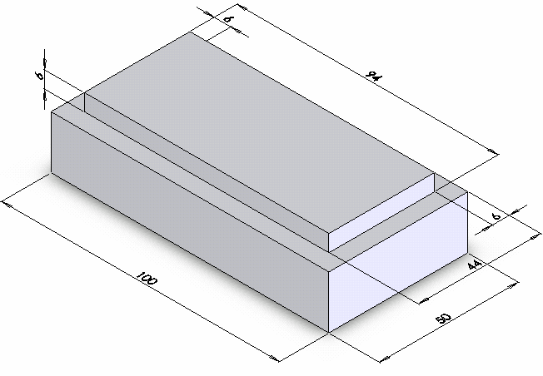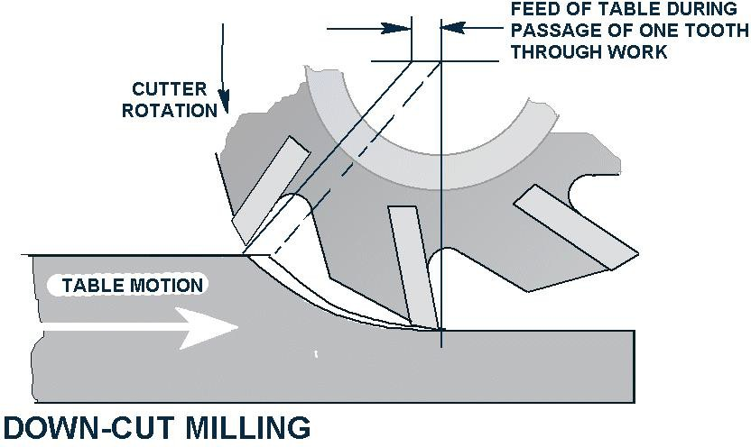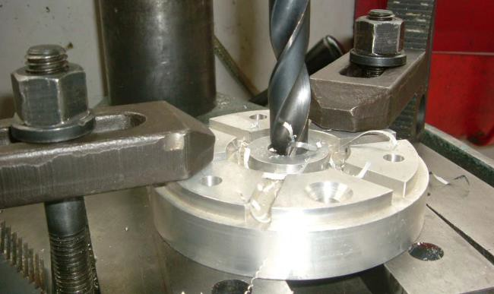

Engineering
Preparation for working in an engineering environment

Individual Research Activity

Student Name ………………………………………………………………….

Welcome to the Engineering Summer Project for 2020.

This individual research activity has been designed to help prepare you for your chosen course. Please attempt to complete all the activities to the best of your ability, using a variety of research methods.

The completed workbook needs to be brought along with you when you are invited in to enrol.

Activity |  | Completed | Assessment
1 | Hazard Spotting
2 | Personal Protective Equipment
3 | Fire
4 | Safety Signs
5 | Engineering Maths & Science
6 | Shape Drawing
7 | Written Essay
8 | ‘Items required’ Checklist

Each activity will be assessed once you have returned the work and feedback will be given during the first few weeks of your course.

Have a relaxing summer break and we look forward to seeing you at the end of August.

HAZARD SPOTTING

What is the definition of a hazard?

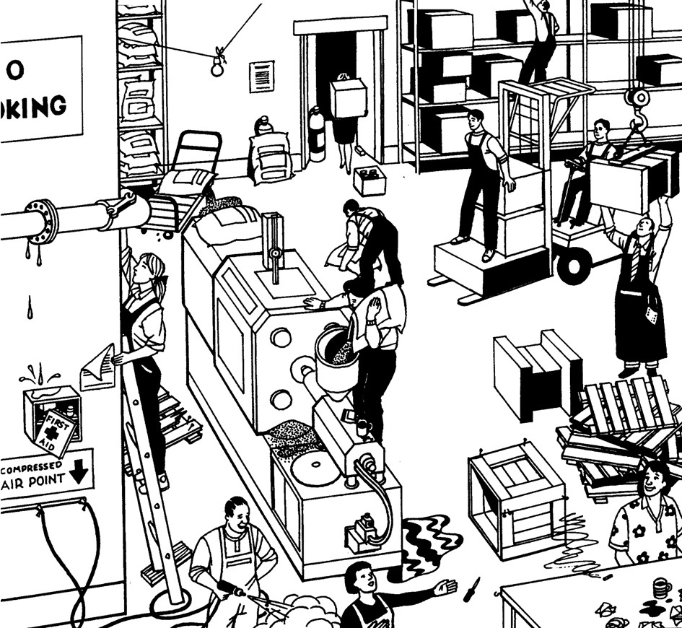
Circle all the hazards you can find on the picture below.

PERSONAL PROTECTIVE EQUIPMENT (PPE)

What is Personal Protective Equipment (PPE)?

The below photo includes examples of PPE: Provide the names of the PPE in the text box below:

:

FIRE

Complete the table below to show which classification of fire each type of extinguisher can be used on.

Class A – Paper, wood and textiles
Class B – Flammable liquids
Class C – Flammable gases, liquids
Electrical Hazards

Why should water or foam never be used on electrical fires?

WWhat would happen if water was used on a fire involving a flammable liquid?

SAFETY SIGNS

Safety signs are used as a quick method to communicate important messages. Four colours are used to help us to quickly identify the meaning of the safety sign.

Blue = Mandatory - means ‘must do’ Red = Prohibition - means ‘do not’ Yellow = Warning - means ‘be careful’
Green = Safe condition - Means ‘ok to do or go to’

Identify the following signs and write in the correct colours. State what each sign is telling you.

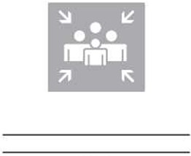

ENGINEERING MATHS & SCIENCE

Complete all questions in the space provided, showing all your workings.

1. | Find the value of the following expression:
 | 2 – 13 = ?
2. | Find the value of the following expression:
 | -11 x -7 = ?
3. | Is the following calculation True or False?
 | 1 – (-1) = 0
4. | Simplify the following fraction into its lowest form:
12

64
5. | Add the following and express your result as a fraction:
1 1
+
3 5
6. | Subtract the following and express your result as a fraction:
2 1
−
3 5
7. | Multiply:
2 1
×
3 5
8. | Divide:
1 1
÷
2 3

9. | Simplify:
 | 𝑥² × 𝑥³
10. | Solve the equation (find the value of 𝑥):
 | 3𝑥 − 6 = 0
11. | Solve the equation (find the value of 𝑥):
𝑥
= 3
5
12. | If a² + b² = c², find the missing length of the following triangle (2d.p. only):
3 5

?
13. | Using trigonometry, determine missing value 𝑥 (2d.p. only):
𝑥
35°
14. | If V = I x R, calculate the missing value and provide your answer with a unit of measurement:
 | V = 24V and R = 4Ω
15. | If M = F x d, calculate the missing value and provide your answer with a unit of measurement:
 | F= 20N and d = 150mm

SHAPE DRAWING

The graph paper provided is divided by lines spaced 5mm and 10mm apart.

Using the given dimensions, and the graph paper provided, accurately draw the correct nets of the required 3D shapes.

- A cube with a volume of 1ml (Example provided)

- A cylinder with a radius of 15mm and a height of 30mm.

- The cross section of the prism must be a right-angled triangle with a height of 40mm and a base of 30mm. The length of the prism must be 70mm.

- A cuboid 20mm long, 10mm high and 30mm wide

- A prism with an equilateral triangle cross section with sides measuring 30mm. The length of the prism is to be 80mm

Page 8

Example

Modern Engineer
Page 9

Why is a good level of Maths, English and science important for the modern engineer?
In the space below, provide a hand-written answer to the following question (approx. 300 words)

Items required for course

 | Stationery and Equipment
Item |  | Level of requirement | Required by: | Tick when obtained
Pen |  | Essential | 08/09/2020
Pocket notebook |  | Essential | 08/09/2020
Notebook/Lined Paper |  | Essential | 08/09/2020
Pencil Case |  | Recommended | N/A
Scientific Calculator |  | Essential | 18/09/2020
Oxford drawing set (or alternative) |  | Essential | 18/09/2020
Fine line pen |  | Recommended | N/A
Paint pen (for writing on metal) |  | Recommended | N/A

