Work Activity Brief

Courses | Applied Science Level 2 & 3
Project Title | Introduction to Science
Tutors | Andy Irvine & Paul Davis
Issue date | April 2020 | Completion date | August 2020

Project overview

This project will help to provide you with a basic introduction to Science before you begin your course at East Surrey College.

At East Surrey College, we encourage our students to be independent learners. This means:
- Being organised
- Being self-motivated
- Being curious to learn
- Being ready to contribute to learning

Why focus on study skills? Because reflecting on HOW we learn, is just as important as WHAT we are learning.

Once you have completed your project, please forward this to the following email address along with your full name: submissions@esc.ac.uk. We’ll then forward this on to our curriculum teams who will be in touch shortly.

Outcome of the project

This project has been developed to help you to prepare for the programme that you will be joining in September. It will hopefully give you some insight into the subject area and develop skills of working independently as you will be required to do as a College student.

Brief – These are the tasks that you need to complete:

Please work your way through this project by completing all exercises. Please write your answers where applicable.

SECTION A: Biology
- The diagram shows a sperm cell.
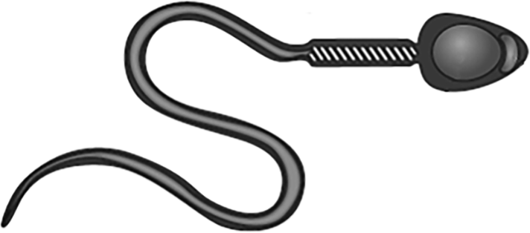
- a. State the function of the cytoplasm. (1 mark)

b. Name the cell component that allows entry and exit of substances. (1 mark)

- Name the cell component where respiration takes place. (1 mark)

- State the function of the tail of the sperm cell. (1 mark)

2. The image shows a chromosome.

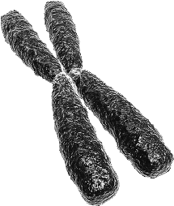

- State where chromosomes are found in a cell (1 mark)

- DNA contains complementary base pairs. Cytosine (C) pairs with guanine (G).
Name the base that pairs with thymine (T). (1mark)

- The allele for brown eyes is B. The allele for blue eyes is b.
A father is heterozygous for brown eyes, and has the genotype Bb.
A mother is homozygous for blue eyes.

Complete the Punnett square using this information. (2 marks)

B
b

mother

father

- Explain ONE beneficial effect of genetic mutations on organisms. (2 marks)

- Name the TWO organs of the central nervous system. (2 marks)

- The diagram shows a reflex arc.
- Complete the labels, A and B, of the reflex arc. (2 marks)
Spinal Cord

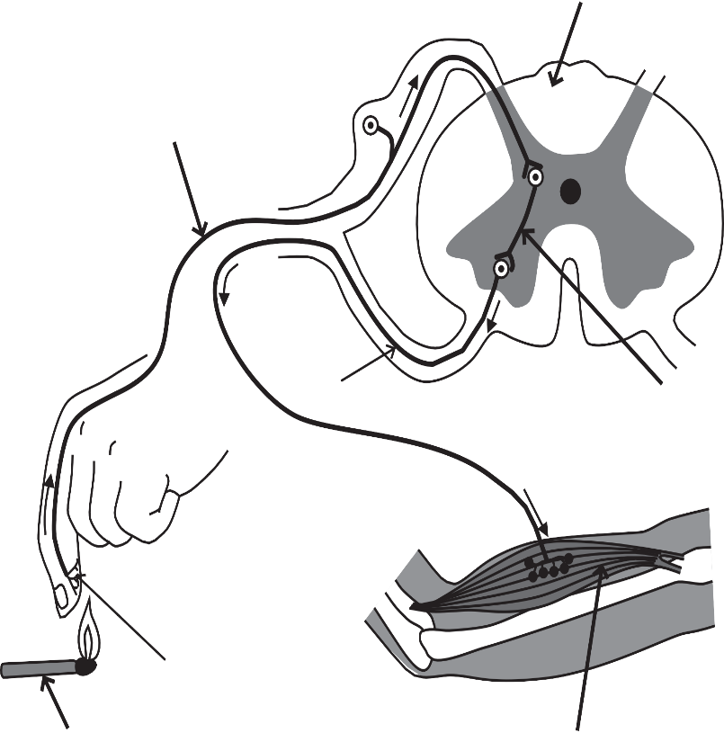
Sensory Neurone

Relay Neurone
B

A

Effector
Stimulus

- The diagram shows a sensory neurone and a relay neurone.

The gap between the neurones is called a synapse.

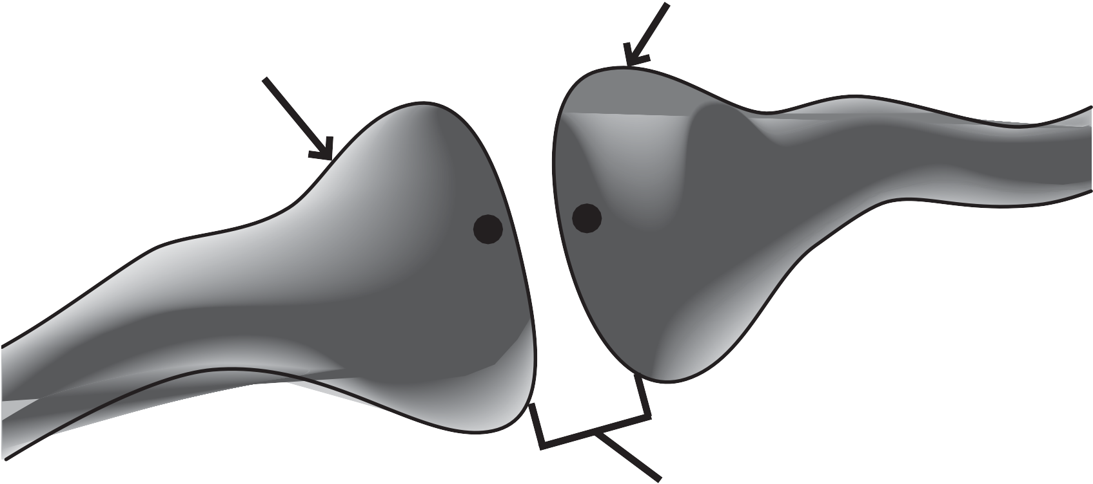
Sensory neurone
Relay neurone
P
Q

Synapse

- Explain how information travels from point P to point Q. (4 marks)

SECTION B: CHEMISTRY
1. The diagram shows four substances, W, X, Y and Z.

Cl Cl
H
H
C
H
H
Fe
O
C
O

W X Y Z

a. Which of the substances are elements? (1 mark)

    - W and X

    - W and Y

    - X and Y

    - X and Z

- Give the letters of ALL the substances from the diagram that are molecules. (1 mark)

- A container of substance X is labelled with this hazard symbol.

State the meaning of this hazard symbol. (1 mark)

- Write the chemical formula for substance Z. (1 mark)

- Hydrogen is an element. Describe the test for hydrogen. (2 marks)

- Sam adds sodium hydroxide solution to hydrochloric acid to form a neutral solution.
He then adds universal indicator solution. State the pH of the neutral solution. (1 mark)

- State the colour of the universal indicator in the neutral solution. (1 mark)

- Indigestion is caused by excess stomach acid.
When indigestion remedies are taken, a neutralisation reaction takes place.
Explain why this is a neutralisation reaction. (2 marks)

- The reaction of zinc oxide with sulfuric acid is another neutralisation reaction.
Complete the symbol equation to show the products of this reaction. (2 marks)

+

ZnO + H2SO4

- The diagram shows some information about sodium.
This information can be used to determine its electronic configuration.
mass number
23
Na
sodium
11

atomic number
Explain the position of sodium in the periodic table, referring to its electronic configuration. (6 marks)

SECTION C: PHYSICS
    - The picture shows a toaster.

- Name the type of energy used to power the toaster. (1 mark)

- Name the type of energy used to toast the bread. (1 mark)

- Name ONE type of energy wasted by the toaster. (1 mark)

- The toaster transfers 138 000 joules of energy in 60 seconds. Calculate the power of the toaster.

power (watts) = energy (joules)
time (seconds)
Show your working. (1 mark)

- Power = W

(1 mark)

- 2. Radio waves and X-rays are two parts of a spectrum of waves.
- a. Name this spectrum of waves. (1 mark)

- State ONE other wave in this spectrum. (1 mark)

- Explain why some healthcare workers stand behind a screen made of lead when taking X-ray images.
(2 marks)

- The speed of radio waves is 3 x 108 m / s. A radio wave has a frequency of 600 000 Hz.
Calculate the wavelength of this radio wave.

wave speed (m / s) = wavelength (m) ×
frequency (Hz)
Give your answer in standd how your working. (4 marks)
Wave Length =

- Fuels are used to provide energy. Biofuels are renewable fuels.
Plants can be used to make biofuels. Fossil fuels are non-renewable fuels.
Fossil fuels can be obtained from under the ground.
Discuss the advantages and disadvantages of using biofuels rather than fossil fuels to provide energy. (6 marks)
Discus

