Work Activity Brief

Course | Maths Level 1 Activity for Beauty
Project Title | Maths for a Career in the Beauty Industry
Issue date | April 2020 | Completion date | August 2020

Project overview

Welcome to East Surrey College. At East Surrey College, we encourage our students to be independent learners. This means:

- Being organised
- Being self-motivated
- Being curious for learning
- Being ready to contribute to learning
Why focus on study skills? Because reflecting on HOW we learn, is just as important as WHAT we learn.

Once you have completed your project, please forward this to the following email address along with your full name: submissions@esc.ac.uk. We’ll then forward this on to our curriculum teams who will be in touch shortly.

Outcome of the project

This project has been developed to help you to prepare for the programme that you will be joining in September. It will hopefully give you some insight into the subject area and will support the development of working independently as well as assignment writing.

These are the tasks that you need to complete, please follow these to help you to structure your work.

You arrive at the Salon and there is a list of jobs you need to do.

Activity 1 - Set up the Float

Task 1. You need £50 in the cash register. Complete the table to check the amount that you have. Is it sufficient?

£10 notes | £5 notes | £2 coins | £1 coins | 50p coins | 20p coins | 10p coins | 5p coins | 2p coins | 1p coins
1 | 2 | 1 | 12 | 12 | 25 | 36 | 20 | 10 | 20
£____ | £____ | £____ | £____ | £____ | £____ | £____ | £____ | £____ | £____

Task 1.2. Total amount in the float:

Activity 2 - Taking payments

Task 2.1 Use the Salon price list below to answer the questions below

Treatment | Price
Dry Cut | £8.20
Cut & Blow dry | £22.10
Deep Conditioning Treatment | £7.85
Beard Trim | £5.00
Acid Perm | £35.00
Full Head Tint | £25.00
Manicure | £8.90
False Nails | £14.75
Long Highlights | £17.25
Underneath Colour | £15.00
Lip Wax | £4.00
Eyelash Tint | £3.50
Massage | £18.50
Hairspray (Salon product) | £4.70
Hair Wax (Salon product) | £5.24
Conditioner (Salon product) | £3.75
Cuticle Oil (Salon product) | £3.99

- Mrs Green has an acid perm and buys a bottle of conditioner. She hands you a £50 note. How much change do you give her?

- Mrs Patel has an eyelash tint and a manicure, she pays with a £20 note. How much change does she get?

- Write down 3 different ways you can give Mrs Patel her change using different coins.

- John comes in for his weekly beard trim and has a dry cut as well. How much does he owe?

- Miss Chen has a massage, and buys a bottle of conditioner. She wants to add a £5 tip. How much does she pay?

- Mrs Williams has a set of false nails and an eyelash tint. She gives a £2 tip. She pays with one £10 note, a £5 note and some coins. What is the value of the coins she gives?

- Mrs Osman buys some hairspray, some hair wax and some conditioner. She has a loyalty card and redeems a voucher for 10% off. How much does she pay?

Activity 3 - Cash up

Before you leave the till, you need to ensure there is still a £50 float and put the extra takings into the safe. This is what you have in the till.

Task 3.1 Create a table like the one in Task 1 to show what you leave in the till for the float.

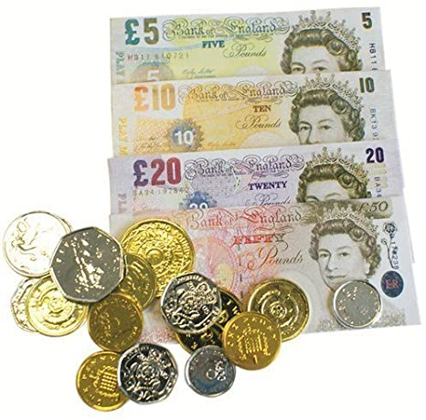

Activity 4 - Bookings

You get into the Salon at 8am on Monday and your Manager is in despair. The person in reception yesterday has made a real mess with the bookings. The Manager asks you to sort out the appointments for the day

Task 4.1
Using the treatment timings and price tables on the following pages:

- Work out how long each session lasts in the appointment book and block out the times.

- Each member of staff has 45 minutes for lunch.

- Emily has called in to book a friend’s massage package. She and a friend would like a full body massage and a facial at the same time as each other. Can you fit them in?

- Add in the appointments that are written on the notice board.

- Work out the cost for each customer. There is a 15% discount for anyone booking 3 or more treatments.

- Which slots are free during the day for walk in appointments?

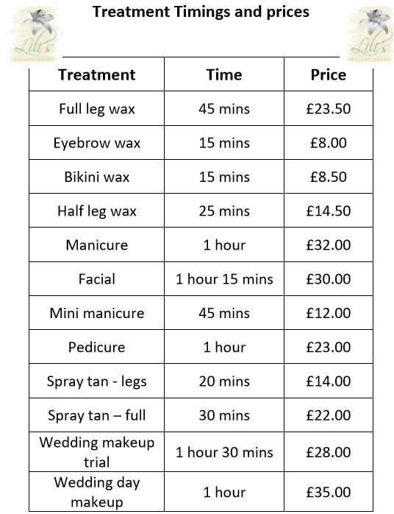

DIARY

 | Jenny | Paul | Meena | Jacquie
09.00 | Mrs Patel eyebrow wax |  | Miss Wall wedding makeup trial | Mr Green Facial
10:00 | Mrs Kowasfel full leg & bikini wax
 |  | Miss Jones half leg wax
11:00 |  |  | Mr Smith mini manicure
 |  | Mrs Zoma manicure
12:00 | Lunch
 |  | Lunch
13:00 | Mrs Mitchell aromatherapy |  | Lunch
 |  |  |  | Lunch
14:00
15:00 | Mr Sebald pedicure
 |  | Miss Ali facial
16:00

NOTICE BOARD

Mrs Jackson

Spray tan, eyelash and eyebrow tint

11am

11am
Lula

Full spray tan

Half nine

Mrs Johnson

Swedish back massage

9am

Suzi Q

Half leg wax

13:45
Frieda

Facial and full spray tan

Half past one

Ms Farge

Facial

Quarter to twelve

Angela Fairfield

Hot stone back massage

Midday

Emily Carter

Full leg & bikini wax

10:30

James

Pedicure

4pm
Ms Sandroff

Reflexology

12:45

