Work Activity Brief

Course | Maths
Project Title | Maths for Public Services
Issue date | April 2020 | Completion date | August 2020

Project overview

Welcome to East Surrey College. This activity will help you to prepare for a career in Public Services. At East Surrey College, we encourage our students to be independent learners. This means:

- Being organised
- Being self-motivated
- Being curious for learning
- Being ready to contribute to learning
Why focus on study skills? Because reflecting on HOW we learn, is just as important as WHAT we learn.

Once you have completed your project, please forward this, along with your full name, to submissions@esc.ac.uk. We’ll then forward this on to our curriculum teams who will be in touch shortly.

Outcome of the project

This project has been developed to help you to prepare for the programme that you will be joining in September. It will hopefully give you some insight into the subject area and will support the development of working independently as well as assignment writing.

Brief – These are the tasks that you need to complete, follow these to help you to structure your work

Task 1 - Stewarding Public Events

The Reigate Music Festival needs to ensure that it has enough stewards for its 2021 festival. The festival lasts for 4 days, with 6 areas where music and other activities are taking place. There are an additional 11 areas that will be used as camping fields for the general public. The organisers are expecting 60,000 people at this year’s event and would like a Steward:Visitor ratio of 1:75

Task 1.1 Using the estimate of total visitors expected, and the required ratio given. How many stewards need to be recruited? You may use a calculator but please show all stages of calculation.

Task 1.2 Stewards will be split into four groups divided into the following ratio:

Gates : Fire Towers : Venue & Stages : Response Group
1 : 2 : 3 : 4

Complete the table to show the number of stewards allocated to each area

 | Gates | Fire Towers | Venue & Stages | Response Group
Total number of stewards

You may use a calculator but show each stage of calculation.

Task 1.3 You are promoted to the role of Supervisor for the team of Stewards allocated to the Magic Meadow Venue. The line up for the bands and the length of their sets is as follows:

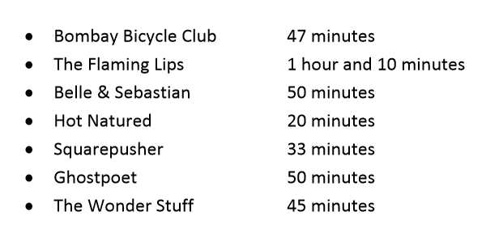

How long will all the sets take to perform in total? Please DO NOT use a calculator for this and show all stages of calculation.

Task 1.4 Bombay Bicycle Club start their performance at 19:00. Allowing a 5-minute gap for set change, create a time plan for the evening performances

Band Name | Start Time | Finish Time

Task 1.5 There are 5 Stewards in your team (Kim, Tony, Ria, Amanda and Sophie) plus you. You need to work out a rota for the shift, which starts at 18:00 and ends at 02:00. The rules are as follows:

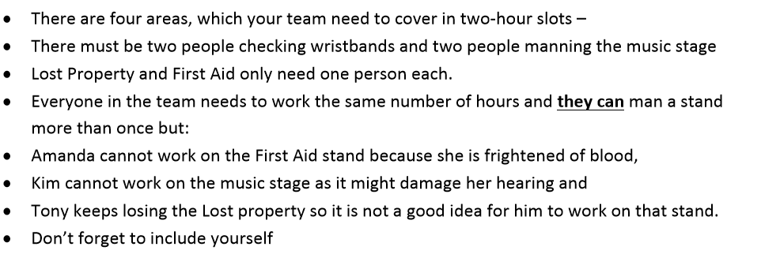

Use the table below to create a rota that follows these rules:

Time | Checking Wristbands | First Aid Stand | Music Stage | Lost Property
18:00 – 20:00
20:00 – 22:00
22:00 – 00:00
00:00 – 02:00

