Work Activity Brief

Course (s) | Motor Vehicle Level 1
Project Title | Introduction to your Motor Vehicle Course
Tutor/s | Richard Ince
Issue date | April 2020 | Completion date | August 2020
Project overview

This project will provide you with an introduction to your Motor Vehicle Course. Please answer all questions and you may use the internet to support you with your findings.

Once you have completed your project, please forward this to the following email address along with your full name: submissions@esc.ac.uk. We’ll then forward this on to our curriculum teams who will be in touch shortly.

Outcome of the project

This project has been developed to help you to prepare for the programme that you will be joining in September. It will give you some insight in to the subject area and assignment writing as well as develop your skills in working independently.

Task 1
Name the below vehicles:

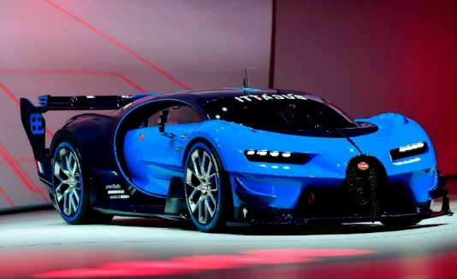

………………………………………… ……………………………………………

Task 2 - To get you settled into your new course. Below is a task to be completed using your research skills

Full Name…………………………………………………………………………………………..

- Give 3 reasons why workshop and classroom rules are required:
1.
2.
3.

- State the name given to a ‘first’ driving licence.

- Identify an organisation that deals with driving licence applications and state at which age a person can apply for their first driving licence.

- State two reasons why a person might be refused a first driving licence.

1.
2.

- Briefly outline the main purpose of the Highway Code.

- Other than book form, state another format which the Highway Code is available in.

Task 3

State the meanings of the following road signs.

A | B | C | D
E | F | G | H
I | J | K | L

Task 4

Prepare for your driving test by researching and completing the following information:

Length/timescale of the theory driving test:
Length/timescale of the practical driving test:
State the format of the driving theory test.

Theory test format:
List two subjects/topics covered in the driving theory test

A
B
- State two tasks / manoeuvres which are part of the practical driving test.

Tasks/manoeuvres A:
Tasks/manoeuvres B:
Locate a driving test centre in your area:

Driving test centre address and contact details:

Task 5

Using the images below:
- Identify the tools.
- Identify the safety checks to be carried out prior to their use.
State how the tools would be used in maintenance and repair

A  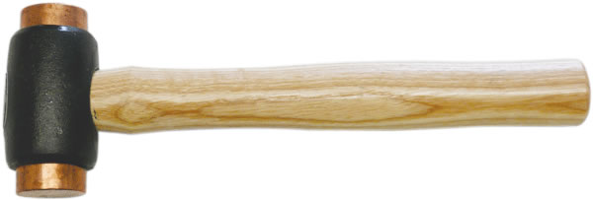 | Type of tool:
 | Use:
B  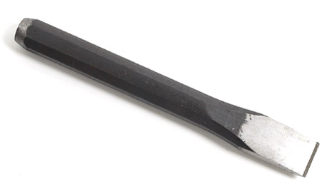 | Type of tool:
 | Use:
C  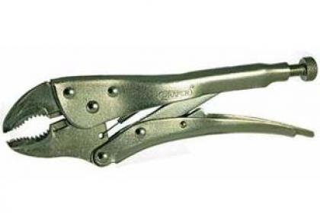 | Type of tool:
 | Use:
D  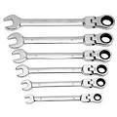 | Type of tool:
 | Use:
E  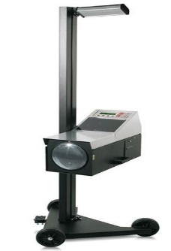 | Type of equipment:
 | Use:
F  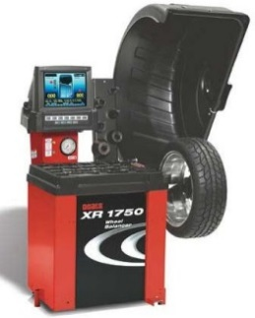 | Type of equipment:
 | Use:
G  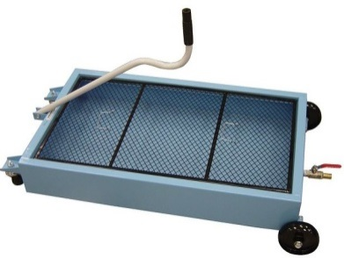 | Type of equipment:
 | Use:
H  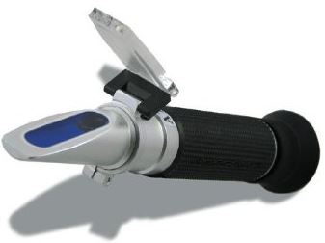 | Type of equipment:
 | Use:

Task 5

A. Explain what is meant by the term carbon footprint.

