Work Activity Brief
Courses | Painting & Decorating Level 1 & 2
Project Title | Introduction to Painting & Decorating
Tutor | Justine Chart
Issue date | April 2020 | Completion date | August 2020

Project overview
This project will provide you with an insight into a course in Painting & Decorating.
Please use the internet to help you answer the questions, and save the document with your full name.

By the end of completing this project, you will be able to have a basic understanding about developing paint finishing skills, surface preparation skills and papering skills.

Outcome of the project
This project has been developed to help you to prepare for the programme that you will be joining in September. It will hopefully give you some insight into the subject area and will support the development of working independently as well as assignment writing.

Painting & Decorating
These are the tasks that you need to complete, and will support you to structure your work
Task 1: Identify and explain the use of all these tools and resources used in preparing surfaces and applying the paint and paper.

Tool/Material | Name | Used for
Tool/Material | Name | Used for
Tool/Material | Name | Used for
Tool/Material | Name | Used for

Task 2 - Questions
- Where would you find information on all current Health and Safety legislation?

- What does PPE stand for?

- Why is it essential to establish and maintain a safe work area at all times?

- Why is it important to maintain your tools and store them in the correct conditions?

- Can you identify the meaning of these 4 types of safety signs?
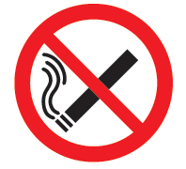 |  | 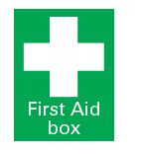
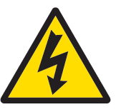

Unit 112: Developing Paint Finishing Skills
Research the below online to answer the following questions
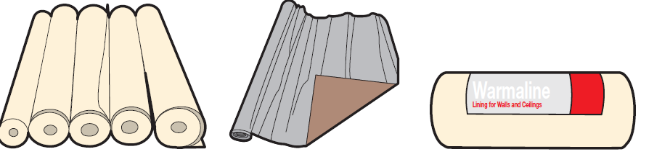
- What are the following types of papers used for?

- Lining paper b) Metal Foil c) Expanded polystyrene

a) _________________________________________________________

b) _________________________________________________________

c) _________________________________________________________

Pasting and Folding

1. What is present in adhesives that prevent mould growth?

2. What two tools can be used to trim wallpaper when applying it to walls?
a) _________________________________________________________

b) _________________________________________________________

3. Explain the importance of keeping a clean and clear working area.

