Work Activity Brief

Course | Maths for any Programme in Construction
Project Title | Maths for Construction Level 1
Issue date | April 2020 | Completion date | August 2020

Project overview

Welcome to East Surrey College. At East Surrey College, we encourage our students to be independent learners. This means:

- Being organised
- Being self-motivated
- Being curious for learning
- Being ready to contribute to learning
Why focus on study skills? Because reflecting on HOW we learn, is just as important as WHAT we learn.

Once you have completed your project, please forward this to the following email address along with your full name: submissions@esc.ac.uk. We’ll then forward this on to our curriculum teams who will be in touch shortly.

Outcome of the project

This project has been developed to help you to prepare for the programme that you will be joining in September. It will hopefully give you some insight into the subject area and will support the development of working independently as well as assignment writing.

Brief – These are the tasks that you need to complete, please follow these to help you to structure your work

Activity 1 - Costing

Diana has a loft in her house that she wants to convert into a bedroom. She finds the following quotes for each aspect of the job.

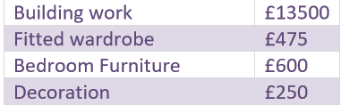

1.1 Without a calculator, work out the total cost. Show all of your workings in the space below:

1.2 Diana is keen to reduce this cost and the builder offers her a 10% discount on £13,500 if she chooses their company over the others. Without a calculator work out the total discount. Show all workings.

1.3 With this discount applied, what is the new total cost?

Activity 2 - Property Value

Diana hears this on the radio:

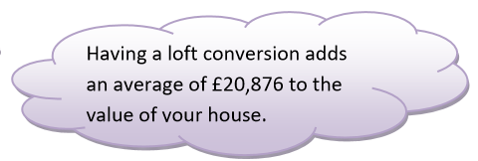

Before the conversion, her house had a value of £194,500. After the loft conversion her house value had increased by 10.5%

2.1 Calculate the new value of her house. You may use a calculator if required, but show each stage of calculation.

2.2 Diana thinks that her house has gained MORE than the average amount. Is she right? Explain reasons for your answer.

